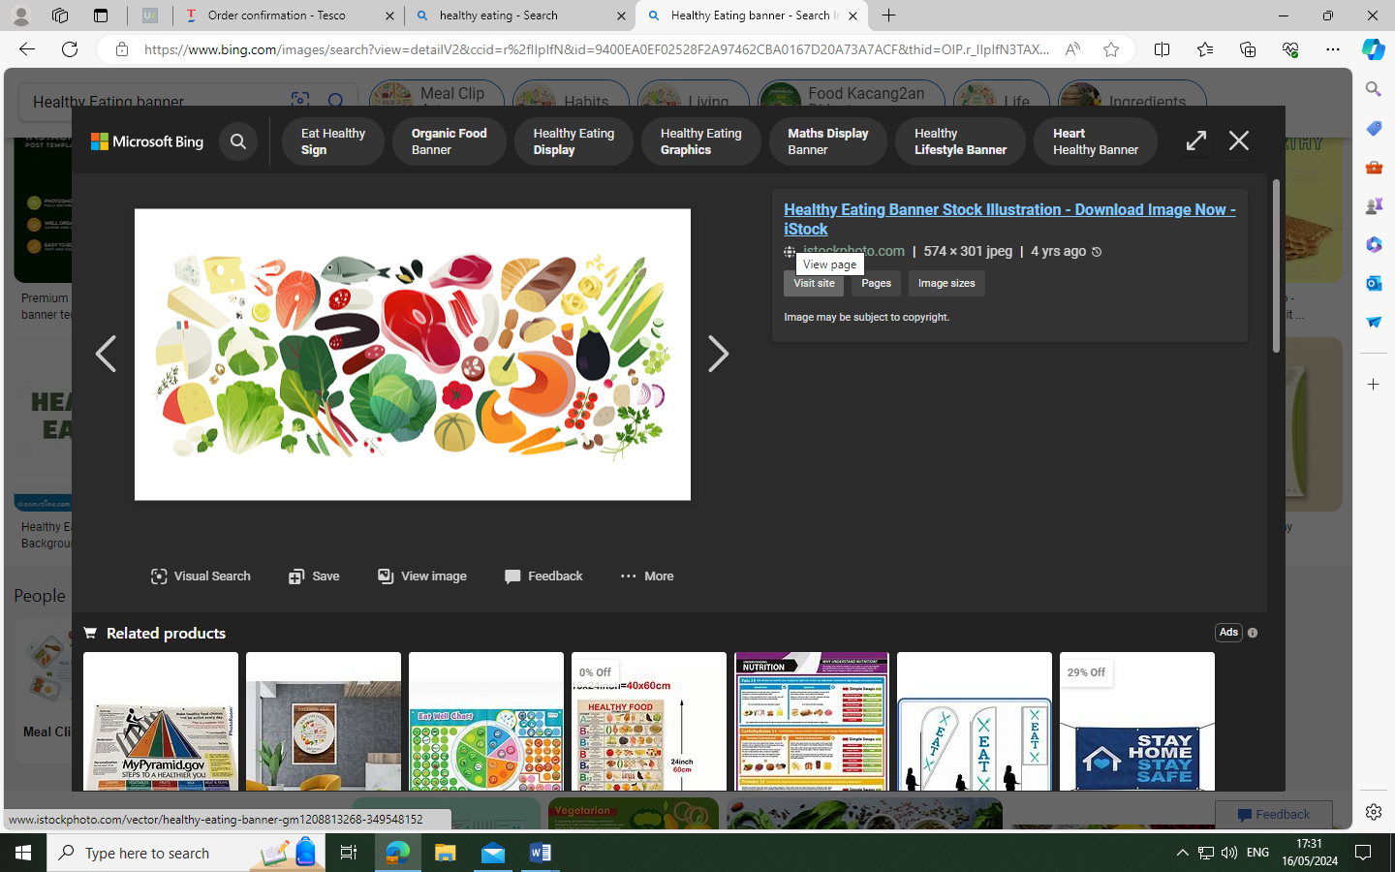

**Residential Summer Menu**

Week 1. 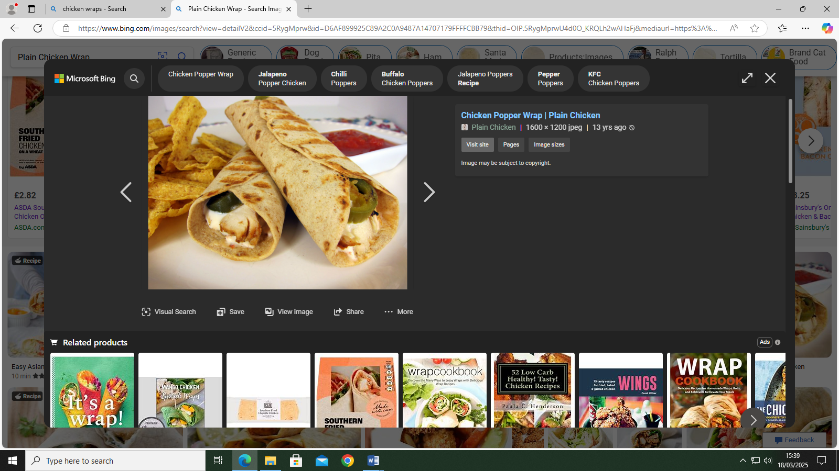 

**Chicken fajita wrap with nachos and sweetcorn**

**Strawberry and vanilla mousse**

Week 2. 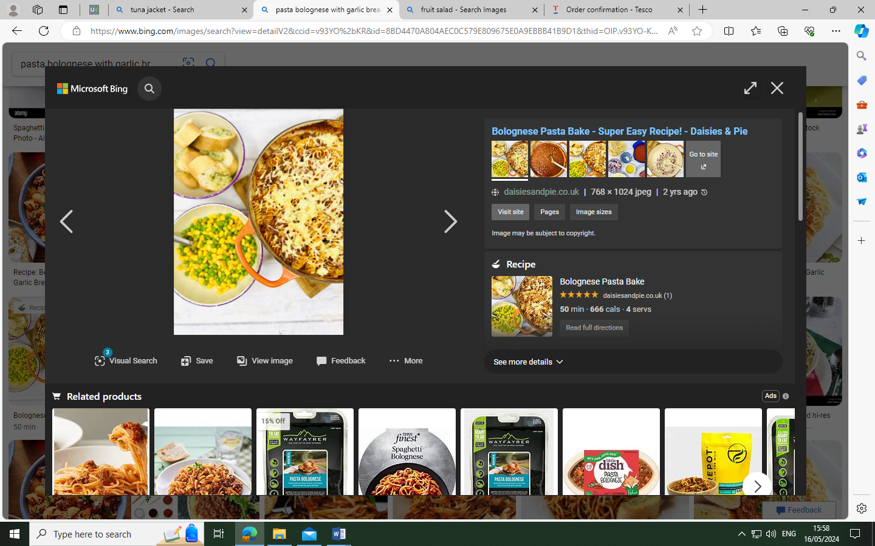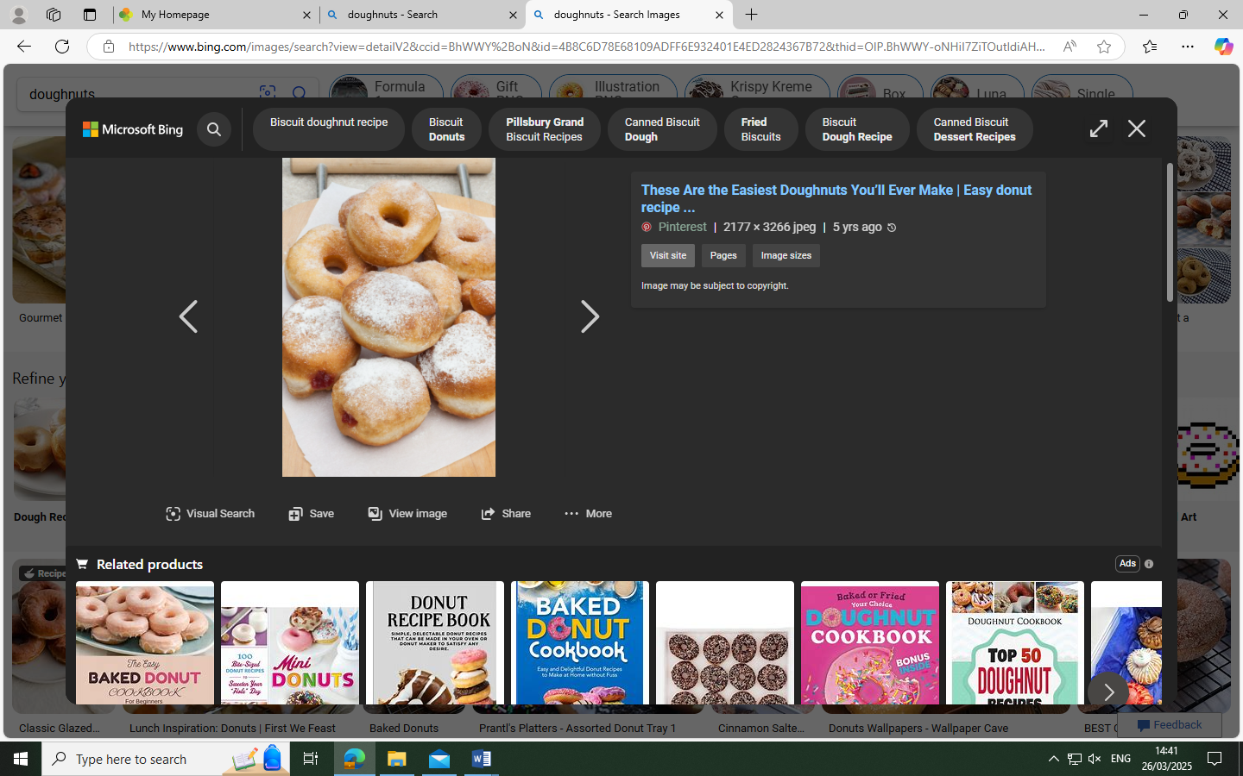

**Bolognaise pasta bake, garlic bread with peas & sweetcorn**

**Doughnut**

Week 3.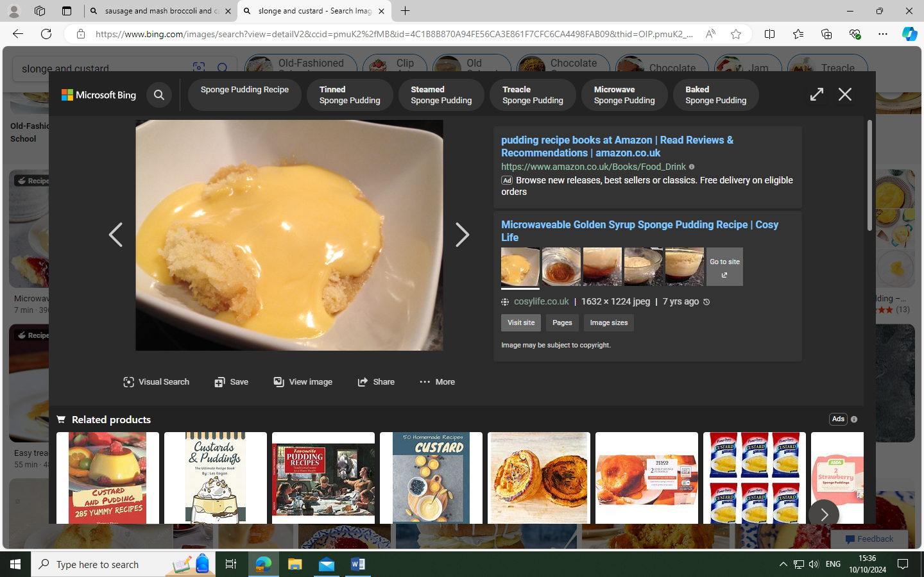

**Chicken burger, homemade wedges and sweetcorn**

**Sponge and custard**

**Available daily, sandwiches, jacket potatoes, filled wraps, salad bar, fresh fruit and yogurts.**

