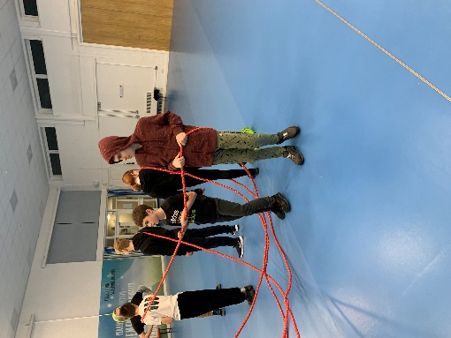

Theme Nights

This term we had a six nation rugby themed night. All the young people had the opportunity to play tag rugby.

Council meeting

This term the councillors meet Charlene and Charlotte to tell us what they enjoyed about Residential and what they learnt. We used this information to make a child friendly statement of purpose.

Dates for the diary:

School closes for pupils Thursday 30th March and re opens Monday 17th of April.

We also have 2 bank holidays early next term: Monday the 1st and 8th of May.

**Residential**

**Spring Newsletter**

**January – April 2023**

Activities this term!

Due to the weather we have spent most of this term indoors. We have joined up with other groups to enjoy Multi- sport. This has included a wide range of gym activities, including an assault course, tag arena and different ball games. We also had an entertainment night when all groups experienced a wide variety of quizzes and games from the best loved TV series, these included; play your cards right and the generation game. At the end of term, we had a visit out to bowling and everyone enjoyed their tea out at McDonalds.

We also completed more independence skills. Year 8’s learnt about personal space and friendships. Year 9’s learnt about First aid, and how our changing bodies. Year 10’s learnt about the importance of cleaning your home and rights and responsibilities. Year 11 learnt how to budget money and how to clean their home.

Staff changes

Unfortunately, this term we have had to say goodbye to a member of the residential team. Susanne has worked with us for a year and will be greatly missed by the staff and pupils.